

C programming Project

PROJECT REPORT

Project title:-Lady Hunter Tiger Game

Submitted By : Harsimar Singh Saluja
SAP ID: 590024470
Course Title: Programming in C
Course Code: CSEG1032
Semester: 1
Batch:-19

Submitted To : Mr. Rahul Prashad

1. ABSTRACT

This project creates a simple Lady Hunter Tiger Game using the C programming language. The game follows a classic concept similar to “Stone-Paper-Scissors,” where:
Lady beats Tiger.
Tiger beats Hunter.
Hunter beats Lady.
The program lets the player pick between Lady, Hunter, or Tiger, while the computer randomly makes its choice. It declares a result for each round and maintains a scoreboard to track the player's wins, computer wins, and draws. The game also has an option to play again, which uses a do-while loop, making it easy for beginners. This project shows how to use conditional statements, loops, random number generation, functions, and basic input/output handling in C. It helps beginners learn how to implement simple game logic and how score tracking works in console-based applications.

2. OBJECTIVE

The main objectives of the Lady Hunter Tiger Game project are:
- To design a simple, interactive console-based C game.
- To allow the user to choose between Lady, Hunter, or Tiger.
- To generate the computer’s choice using the rand() function.
- To determine the winner using conditional logic.
- To maintain a scoreboard throughout multiple rounds.
- To implement a play-again feature using a do–while loop.
- To give beginners hands-on experience with decision-making and program flow in C.

3. PROBLEM DEFINITION
In many small logic-based games, users play manually without any automated opponent or proper scoring. Manually deciding outcomes and maintaining score can be confusing and time-consuming.
Problem:
There is no simple computerized version of the Lady-Hunter-Tiger game that:
- Accepts user input
- Generates computer decisions automatically
- Declares the winner
- Maintains a scoreboard
- Allows multiple rounds

4. SYSTEM DESIGN AND ALGORITHM

Data Used
The program makes use of:
- Integers — to store choices and scores
- Random Number Generation — for computer choice
- Loops — to repeat the game
- Conditional Statements — to decide the result
Game Rules:
- Lady wins over Tiger
- Tiger wins over Hunter
- Hunter wins over Lady
- Same choice → Draw
Algorithm
Step 1: Start the program.
Step 2: Initialize score variables:
- playerScore = 0
- computerScore = 0
- draws = 0
Step 3: Use a do–while loop to repeat the game.
Step 4: Display choices (1: Lady, 2: Hunter, 3: Tiger).
Step 5: Read user choice.
Step 6: Generate computer choice using rand() % 3 + 1.
Step 7: Compare choices using game rules and update score.
Step 8: Display round result and scoreboard.
Step 9: Ask user if they want to play again.
Step 10: Loop continues if user enters ‘y’ or ‘Y’.
Step 11: End program.
Flowchart:- 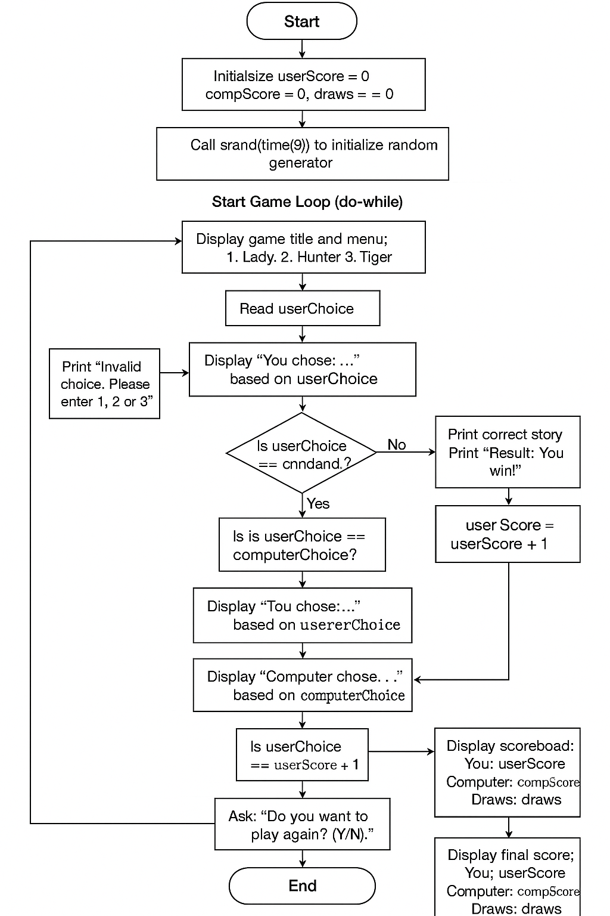

5. IMPLEMENTATION DETAILS
The game is implemented in C using basic concepts such as:
- printf() and scanf() for input/output
- rand() and srand() for random number generation
- do–while loops for repeated gameplay
- if–else statements for decision making
- A scoreboard maintained using simple integer counters
This structure makes the program easy to understand and perfect for beginners.
6. Source Code
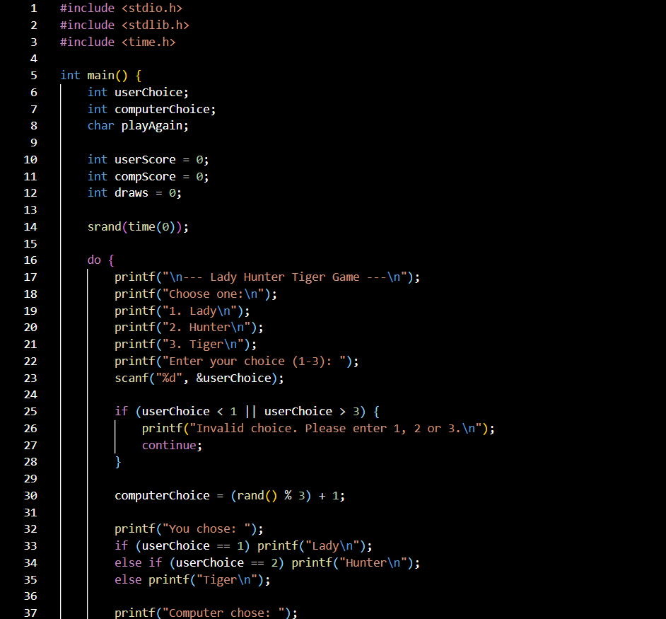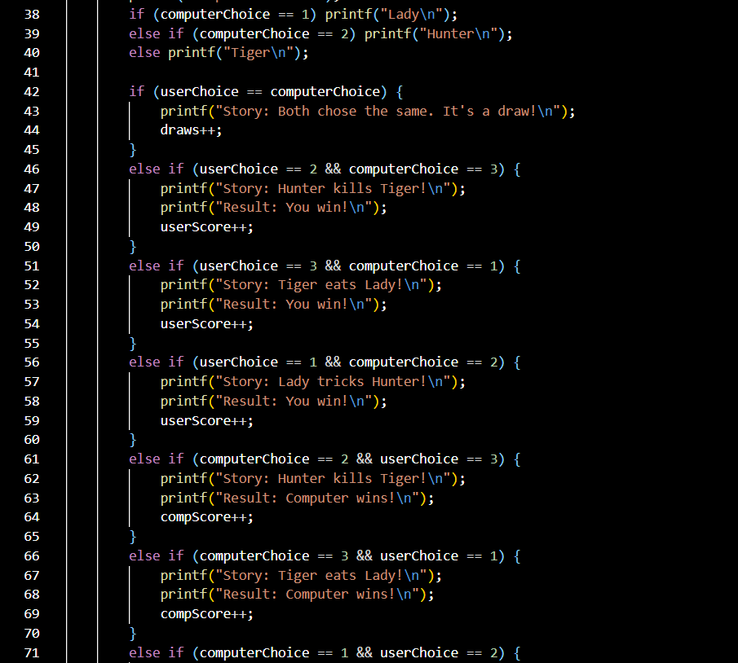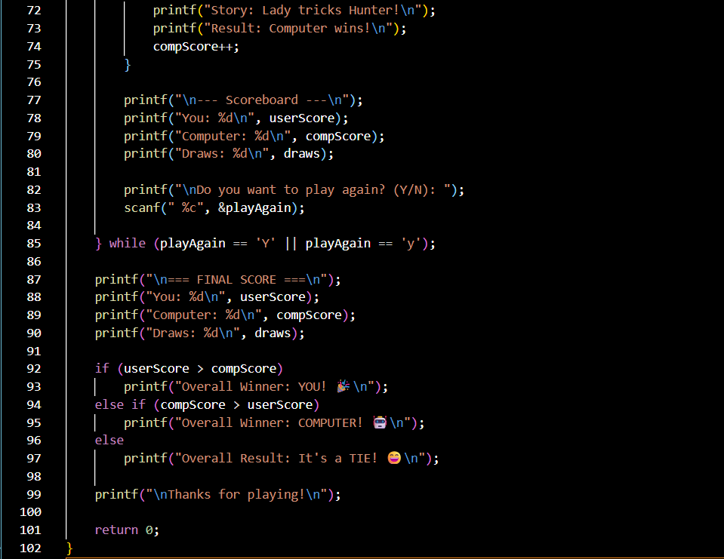

7. TESTING AND RESULTS

Round 1:
Player Chooses: Lady
Computer Chooses: Tiger
Result: Player Wins
Round 2:
Player Chooses: Hunter
Computer Chooses: Lady
Result: Computer Wins
Sample Scoreboard:
Player Wins: 1
Computer Wins: 1
Draws: 0
Tested conditions include:
- All three possible choices
- Continuous gameplay
- Correct scoreboard updates
- Randomness of computer choice
- Proper restart loop functionality
All tests show correct and expected behavior.

8. CONCLUSION AND FUTURE SCOPE
The Lady Hunter Tiger Game successfully demonstrates basic game logic using C programming. It provides a simple, interactive experience while helping beginners understand:
- Loops
- Random number generation
- Conditional logic
- Score tracking
Future Scope:
- Add advanced menu system
- Add animations or sound
- Add difficulty levels
- Add a best-of-5 or best-of-10 mode
- Use file handling to save the scoreboard
- Convert into a graphical game in future using SDL or OpenGL

9. REFERENCES
- The C Programming Language — Kernighan & Ritchie
- Class Lecture Notes
- Standard C Documentation (cppreference.com)

